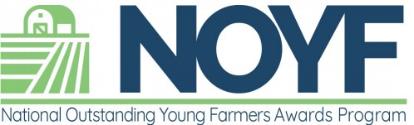
Tammy Cheely
Outstanding Young Farmer Liaison

As with everything, the National Outstanding Young Farmer program made some changes to the normal routine to address issues brought on by Covid -19. They could not hold an in-person awards congress. The Executive Board and Coordinators decided to do the next best thing and judge applicants virtually. The finalists of the Class of 2021 will be announced and honored at the 2022 Congress along with the Class of 2022. This unique Congress, honoring two classes at once, will be held at the Omni Hilton Head Oceanfront Resort on February 3 – 6, 2022.

It’s time again to nominate your young farmers for the 2022 awards year. Eligible nominees must not reach age 41 by January 1, 2022. All of the information as well as the application is on the National Outstanding Young Farmer website: www.ofafraternity.org. The deadline is August 1, 2022.

The NOYF program selected the first group of national winners in 1955. This is an elite group that has stood the test of time! Please help keep it going with your nominations. Remember, if you nominate a national finalists, NACAA will contribute financially towards your travel to the Awards Congress. This event is a great experience! Do not hesitate to reach out to me for help and support with the application process.

