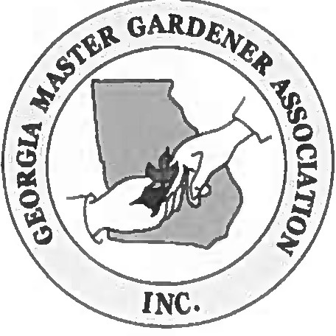
Georgia Master Gardener Association Award of Excellence

For Outstanding Support for
Georgia Master Gardener Extension Volunteers

2020 Entry Form
Deadline 2 September 2020

Name

(If selected, how do you prefer your name on your certificate?)
Address |  | County
City | State: GA | Zip
Phone # | Cell # | FAX #
E-mail Address:

My signature verifies that I am a member of the Georgia Association of County Agriculture Agents with an active GAMGEV program.

Signature Date _

Applicant shall submit photo and biography and sign the Media Release form attached to the Entry Form.

Recipient must commit to attending both the Georgia Master Gardener Association Conference on October 16 & 17, 2020
and the Georgia Association of County Agriculture Agents annual meeting on November 12, 2020.

Send completed application to Sheri Dorn, Consumer Horticulture Extension Specialist and State MGEV Program Coordinator, at sdorn@uga.edu no later than 11:55 p.m. on 2 September 2020.

Recipients will be notified by 1 October 2020.

- Entries will be initially evaluated by a team of agents and GMGA representatives.
- Applicant must be a member of GACAA in the year of submission and coordinating an MGEV program.
- Applicants must commit to attend both the GMGA Conference on 16 & 17 October, 2020 and the GACAA annual meeting on 12 November 2020 in the event they are the winner.

ENTRY AND JUDGING CRITERIA (limit 500 words)

Submit a five-hundred (500) word description of the past years' programming addressing the bulleted points described below.

- Describe the key consumer programs for which you have provided leadership and that MGEVs have delivered during the course of the last twelve (12) months. Describe specific programing efforts in one or more of the state initiative areas, such as environmental stewardship, gardening with youth, home food production, health benefits of gardening, and value of landscaping (Georgia State Initiatives descriptions can be found online at Extension.uga.edu/programs-services/Georgia Master-Gardener-Extension-Volunteer- program/our-impact.html). Programing efforts might include but not be limited to speakers' bureau presentations, workshops, interpretive demonstration gardens, or written campaigns including newsletters, publications, and web materials that you have developed or distributed related to consumer horticulture.

- Describe highlights in your training and preparation of MGEVs This would include introduction/ basic training, any Advanced Training you have offered for MGEVs to strengthen consumer horticulture programming, a continuing education program, or program-specific training.

- Describe outstanding volunteer accomplishments within your MGEV program over the last twelve (12) months. You can use metrics obtained from MGLOG, but might include more than volunteer service hours and the number of volunteers.

- Describe how your leadership creates exemplary MGEV performance in your county. Consider how you regularly communicate with your volunteers, how you present the vision for consumer horticulture, and how you motivate volunteers.

- Describe how you promote MGEV program accomplishments in your county.

- Describe what distinguishes your consumer horticulture programming and the MGEVs program in your county.

Application must be limited to five-hundred (500) words and can include one (1) page referencing supporting materials, such as printed programs, books or bulletins, posters, videos, CD, DVD, website, etc.

AWARD

The winner will receive recognition at the GMGA annual conference and the GACAA annual meeting. The recipient is requested to share with GMGA by speaking at the annual conference, meeting with the GMGA Board, and/or writing an article for the GMGA newsletter.

GMGA will provide the winner with one night's lodging on the night prior to the GMGA Conference to accommodate winner's presence at the GMGA Conference on October 16 & 17, 2020.

JUDGING PROCESS

- Applicants cannot be members of the judging team
- Judging Team – three (3) GMGA MGEV representatives and two ( 2) non-MGEV members of the Advisory Panel
- Notification of the Award criteria and Application form will be made available no later than 1 June 2020.
- Deadline date for submission 2 September 2020 11:55 PM
- Winner to be notified by 1 October 2020

